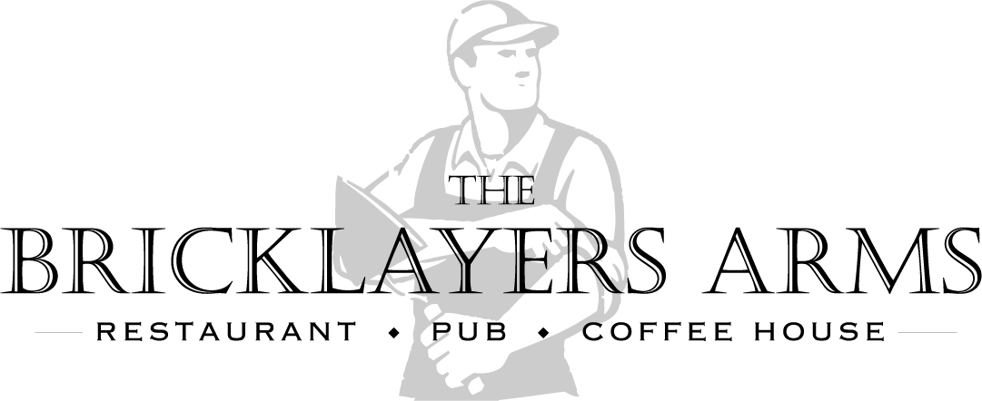
Christmas Day Menu Booking Form 2025
£80 per person/£40 per child under the 12
11.30 arrival for 12.30 sit down

NAME___________________________________________ Party Size______

TELEPHONE NO.___________________________________

EMAIL ADDRESS___________________________________

PLEASE INDICATE THE QUANTITY REQUIRED FOR YOUR PARTY BESIDE EACH OF THE CHOICES FOR STARTERS, MAINS & DESSERTS BELOW.

STARTERS
Red Pepper & Tomato Soup. G, E, M ___________
(Vegan option). ___________
Camembert. G, E, M ___________
Prawn Cocktail. G, E, M ___________
Pate. G, E M ___________

MAINS
Carvery. ___________
Salmon. G, E M ___________
Lamb Shank. G ___________
Chestnut Roast. G ___________

DESSERT
Christmas Pudding, G, M, N ___________
Cheesecake, G, E. M, ___________
Choc/Orange Tort. G ___________
Cheese Selection. G, E M ___________

Additional Information (please use this box to tell us if any of your party have and specific dietary requirements, allergens or mobility issues we need to be aware of at time of booking and, more importantly, prior to the day.)
Terms & Conditions
A non-refundable, non-transferable deposit of £25 per person is required at the time of booking. All parties are pre-payable and full payment, final numbers and completed pre-order forms are required by Friday 12th December 2025. Once full payment has been received, the booking is confirmed, and no refunds or amendments will be allowed. Should any reduction in final numbers take place, refunds will not be made, nor will the money be offset against any other services or additional guests, for no shows on Christmas day no monies will be refunded. Organisers are requested to make their guests aware of this. If pre-orders for every attendee are not received by the given date a default menu will be selected for them. No amendments can be made to pre-orders after Friday 12th December 2025. If booking on behalf of a group, the organiser is responsible for collecting payment and pre-orders and getting them to us by 12th December

For further information telephone 01205870657 or email; bricklayersarmsboston@yahoo.com

